ZOOM

Installation guide

Table of Contents

Zoom 2

Purpose of the document 2

System specification details 2

Operating System 2

Hardware 2

Network Requirements 2

Software Requirements 2

Installation - Zoom desktop client 2

Uninstall - Zoom desktop client 3

# Zoom

Zoom unifies cloud video conferencing, simple online meetings, and group messaging into one easy-to-use platform

# Purpose of the document

The purpose of the document is to help install and uninstall Zoom desktop application.

# System specification details

## Operating System

* Windows 7 or later
* macOS X with macOS 10.9 or later
* Ubuntu 12.04 or higher, Fedora 21 or higher, or Debian 8.0 or higher for Linux

## Hardware

* Processor: Intel i5 or higher recommended for Windows and Mac; AMD Ryzen 5 or higher recommended for Linux
* RAM: 4GB or more
* Hard disk space: At least 200 MB of free disk space for installation

## Network Requirements

* A stable internet connection with at least 1 Mbps upload and 1 Mbps download speed
* For best performance, a wired Ethernet connection is recommended, but Wi-Fi can also work
* Firewall and proxy settings should allow Zoom to connect to the internet

## Software Requirements

* A web browser, such as Google Chrome, Mozilla Firefox, or Safari
* A microphone and speakers, or a headset with a microphone for audio input and output

# Installation - Zoom desktop client

* Open web browser, enter <https://zoom.us/> in address box
* Click **Resources,** and then click **Download** Zoom Client

*Note: You can also directly access the Download Centre*

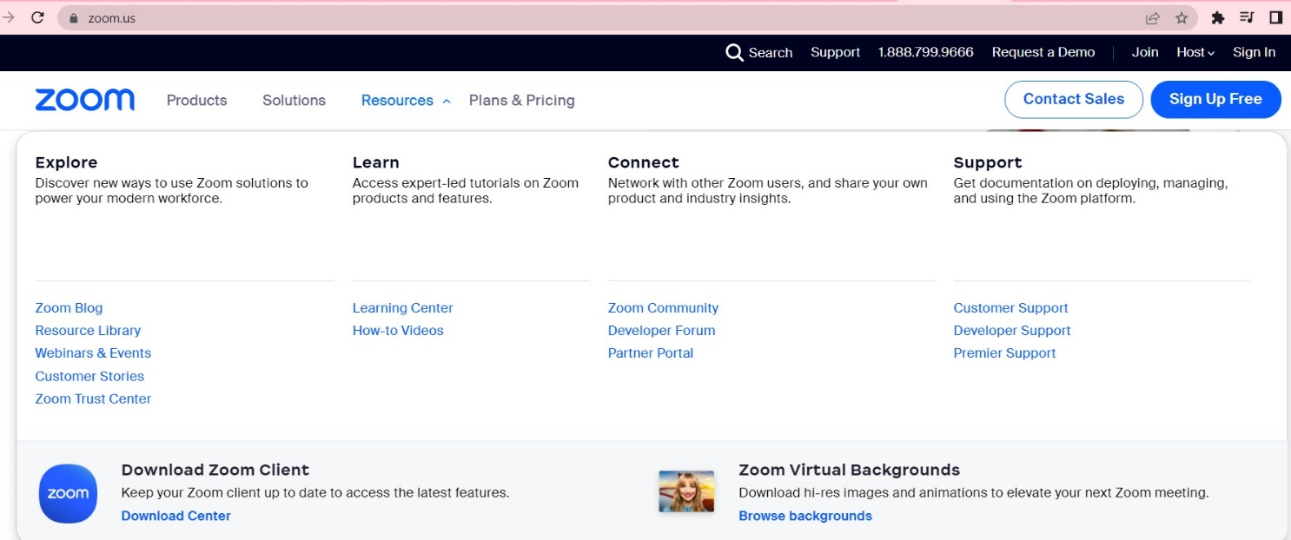

Figure

* Click the **Download** button, below **Zoom Desktop Client**

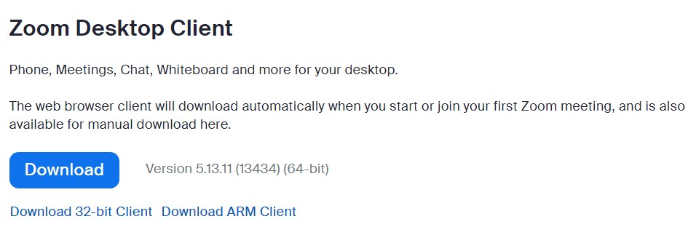

Figure

*The Zoom installer will automatically start downloading the Zoom desktop client (ZoomInstallerFull.exe). If downloading doesn’t start, double-click the Zoom installer to begin the desktop client install*

*Note: After the Zoom desktop client installation is complete, a Zoom icon will appear on your desktop*

* Complete installation process
* Double-click **Zoom** desktop icon to begin using Zoom

# Uninstall - Zoom desktop client

* Search for **Control Panel**, in Windows search bar
* Click **Control Panel** app
* Click **Uninstall** **a Program,** if **Control Panel** is set to Category view

Or

* Alternatively, click **Programs and Features**, if View by is set to large or small icons
* Select **Zoom** in programs list, and then click **Uninstall**
* Click **Yes** for confirmation, if prompted

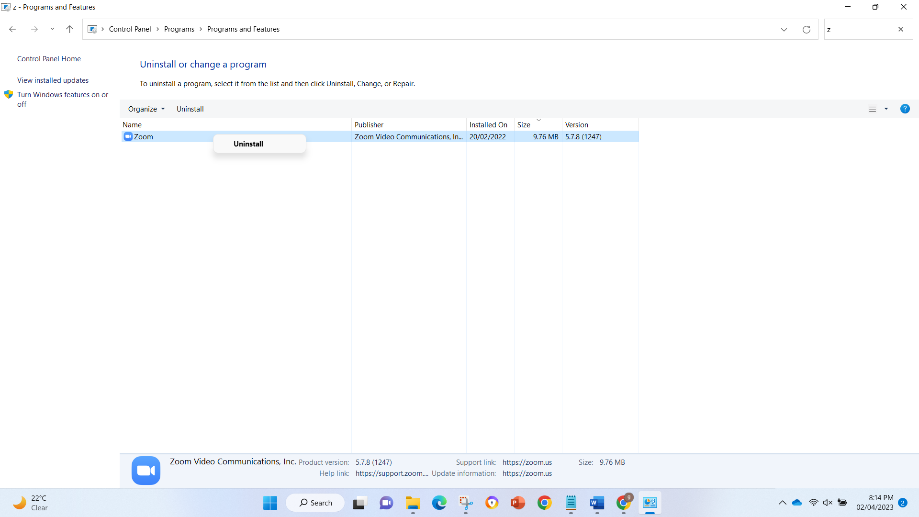

Figure